# Foundation VS Boostrap



# Vergelijking

|  |  |  |
| --- | --- | --- |
| **Parameters** | Bootstrap | Foundation |
| **Huidige versie** | V 4.0 Beta 2 | V 6.4.3 |
| **Preprocessors** | Less en Sass | Sass |
| **Grid system** | Flexbox | XY Grid  Float Grid  Flex Grid |
| **Customization** | Basic GUI customizer | Basic GUI customizer |
| **Community** | + 118.000 op Github | + 26.600 op Github |
| **Browser support** | Chrome, Safari, Firefox Opera, IE9+ | Chrome, Safari, Firefox Opera, IE9+ |
| **Design** | Aanpasbaar en  Verscheidenheid aan ontwerpen | Aanpasbaar en klein aanbod aan ontwerpen |
| **Normalization/ Reset** | reboot.css | normalize.css |
| **Inline forms** | Ja | Nee |
| **License** | MIT | MIT |

# Interesse



# Syntax

|  |  |  |
| --- | --- | --- |
|  | Boostrap | Foundation |
| Enkele kolom | * .col-xs-1 * .col-sm-1 * .col-md-1 * .col-lg-1 * .col-xl-1 | * .small-1.columns * .medium-1.columns * .large-1.columns * .[custom]-1.columns |
| Container | * <div class="container"> * <div class="container-fluid"> | * <div class="row"> |
|  |  |  |
|  |  |  |
|  |  |  |
|  |  |  |
|  |  |  |

# Voordelen

|  |  |
| --- | --- |
| Boostrap | Foundation |
|  |  |
|  |  |
|  |  |
|  |  |
|  |  |
|  |  |
|  |  |

# Grid System

|  |  |
| --- | --- |
| Bootstrap syntax | Foundation Syntax |
|  |  |

|  |  |
| --- | --- |
| Foundation block grids kan een <ul> in een grid veranderen. |  |

|  |  |
| --- | --- |
| Foundation kan kolommen makkelijk centreren met de centered columns syntax. | Bootstrap gebruikt offset om de kolommen te centreren. Je moet de offset berekenen gelijk aan de helft van de resterende grootte. |
|  |  |

**Conclusie:** De syntax voor de grid system is lichtjes anders. Foundation kan ook een <ul> in een grid veranderen en bij Bootstrap kan dat niet. Bootstrap kan centreren maar moet je de offset berekenen terwijl bij Foundation dat je niets moet berekenen en enkel centered moet schrijven.

## Sizing Units

|  |  |
| --- | --- |
| Bootstrap maakt gebruik van pixels terwijl Foundation gebruik maakt van rems. Ze kunnen beidde hetzelfde resultaat opleveren.  Gebasseerd op een 16px browser default:  16px = 1em  (1em x 16px browser default = 16px)  24px = 1.5em  (1.5em x 16px browser default = 24px)  32px = 2em  (2em x 16px browser default = 32px)  html {font-size: 100%} /* 16px default */ |  |

## Features and Components

Foundation heeft een ingebouwde formulier validatie door Abide. Dat wil niet zeggen dat Bootstrap ook geen formulier validatie kon hebben, maar de pre-made Foundation oplossing maakt dit makkelijker. Mogelijke validatie zijn:

|  |  |
| --- | --- |
|  | De definities van de patronen wordt in regex opgemaakt. |

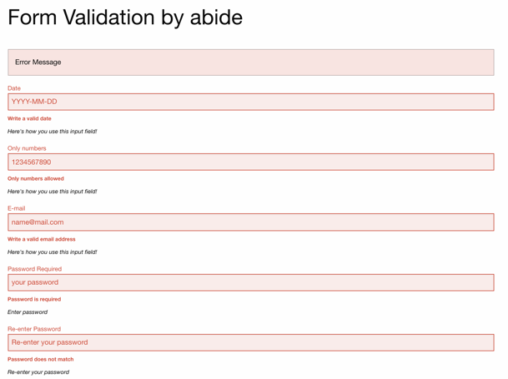

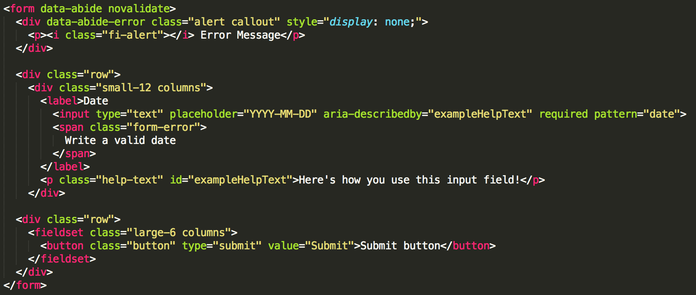

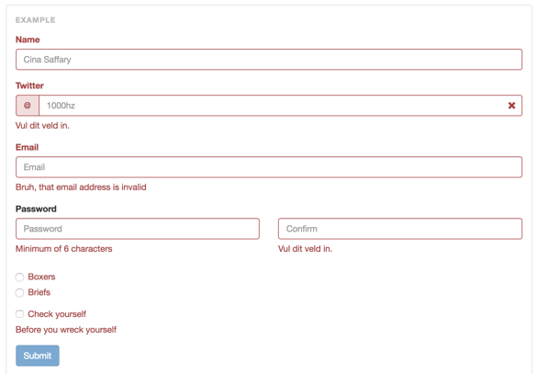

Door gebruik te maken van een plugin kan Bootstrap ook formulier validatie doen. Het zit er dus niet standaard in.

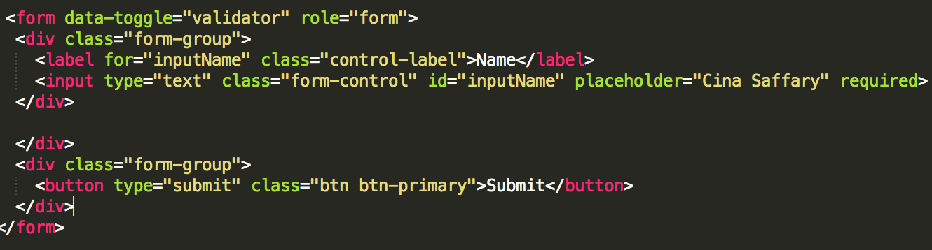

Foundation also includes Interchange, which is a robust solution for responsive images, altough it might be more than you need. In addition to these two, there’s other handy features like right-to-left support, pricing tables, tours and off-cancas navigation.

Bootstrap isn’t quite as feature-full, but in my own opinion, I also feel like many of Bootstrap’s features are in a more complete state. The default look of Bootstrap components seems more suited to quickly building a one-off website and adding a theme. Bootstrap also now includes responsive embeds, which makes it easy to add responsiveness to elements like <iframe>, <embed> and <object>.

**Conclusion:** Foundation has built-in form validation (Abide). Foundation includes interchange (robust solution for responsive images). Bootstrap isn’t feature-full but the features they have are in a more complete state. Default look of Bootstrap components suites quickly building a one-off website and adding a theme. Bootstrap includes responsive embeds which makes it easy to add responsiveness to elements.

## Customization

Bootstrap tries to give you everything you need to get a site up and running quickly, while Foundation tends to provide a better environment for customization. Bootswatch provide free themes of Bootstrap. Bootstrap tends to make sites that look like they were made with Bootstrap. It’s only after digging deep into custom styling that the default look starts to fade. Bootstrap is underscored by the fact that Bootstrap gained more early popular a few years ago. Foundation’s default look feels closer to browser defaults in many cases, which makes it easier to mold into a unique aesthetic. Bootstrap has a wider variety of themes readily available.

**Conclusion:** Bootstrap tries to get a site up running quickly with a wide variety of themes that you can find on Bootswatch. Bootstrap makes sites look like they were made with Bootstrap only after digging deep into custom styling the default look starts to fade. Foundation default look feels closer to browser defaults makes it easier to mold into a unique aesthetic.

## Browser Support and Performace

For both frameworks is so good that the diffrences are almost negligible and are highly dependent on the context. Some permutation of different framework components and browser environments might have a trivial performace gap. The important diffrences revolve around features that support designers and developers.

**Conclusion**: Both frameworks perform good that the diffrences are almost negligible and are dependent on the context. The important diffrences revolve around features that support designers and developers.

## CSS Preprocessor and JavaScript

Both frameworks are based on SASS. They both have a nice set of mixins, a separate settings sheet, reusable components etc. Both frameworks Javascript are written on the latest ES, which meand you do need Babel or any other transpiler if you want to individually include each of their JS tools into your development pipeline. Bootstrap is a little bit ahead when it comes to JS because their components are simpler, less bloated and well tested. Foundation has way more JS toys to play with, which is always handy. Both frameworks allow you to choose which JS components you want if you decide not to use Babel. Foundation was rewritten early ago which has given it enouch time to iron out any issues and bugs thanks to the community.

**Conclusion:** Both frameworks are based on SASS and written in the latest ES and allow you to choose which JS components you want if you decide not to use Babel.